Questions: Trigonometry (degrees)
Dzhemma Ruseva, Ellie Gurini, Ciara Cormican
Summary
A selection of questions on trigonometry, where angles are measured in degrees.
Before attempting these questions, it is recommended that you read Guide: Trigonometry

Q1
You are given the triangle below.
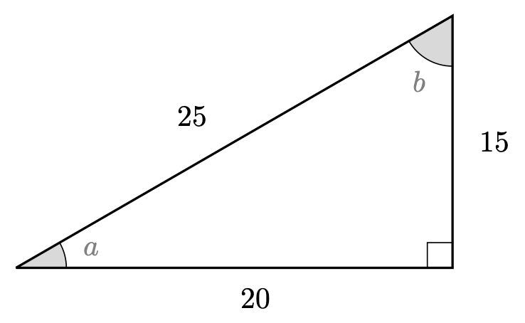
Q1. Triangle
Find $cos$, $sin$ and $tan$ of both $a$ and $b$.

Q2
Using the triangle below, solve the following equations.
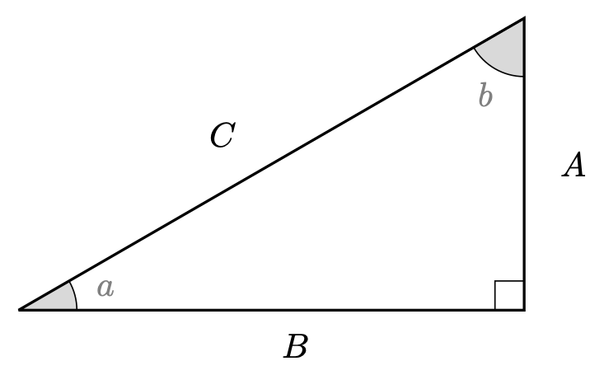
Q2. Triangle
2.1. If angle $a$ is ${30}^{∘}$ and $B=6$, what length is $C$?
2.2. If angle $b$ is ${45}^{∘}$ and $C=2\sqrt{2}$, what length is $A$?
2.3. If angle $a$ is ${15}^{∘}$ and $C=7$, what length is $A$?
2.4. If angle $b$ is ${30}^{∘}$ and $C=2\sqrt{2}$, what length is $A$?
2.5. If angle $a$ is ${45}^{∘}$ and $B=8$, what length is $A$?
2.6. If angle $a$ is ${45}^{∘}$ and $A=8$, what length is $B$?

Q3
Without using a calculator if possible, give the values of the following expressions.
3.1. $cos\left(30\right)$
3.2. $tan\left(30\right)$
3.3. $csc\left(45\right)$
3.4. $cot\left(30\right)−sin\left(60\right)$
3.5. $sin\left(90\right)+cos\left(180\right)$
3.6. $tan\left(30\right)−cot\left(30\right)$
3.7. $cos\left(0\right)sin\left(90\right)$
3.8. $cos\left(30\right)sec\left(30\right)−sin\left(45\right)csc\left(45\right)$
3.9. $cot\left(90\right)$

After attempting the questions above, please click this link to find the answers.

Version history and licensing
v1.0: initial version created 08/23 by Dzhemma Ruseva, Ellie Gurini, Ciara Cormican as part of a University of St Andrews STEP project.
- v1.1: edited 05/24 by tdhc, and split into versions for both degrees and radians.
This work is licensed under CC BY-NC-SA 4.0.

