Factsheet: Poisson distribution
Michelle Arnetta and Tom Coleman
Summary
A factsheet for the Poisson distribution.
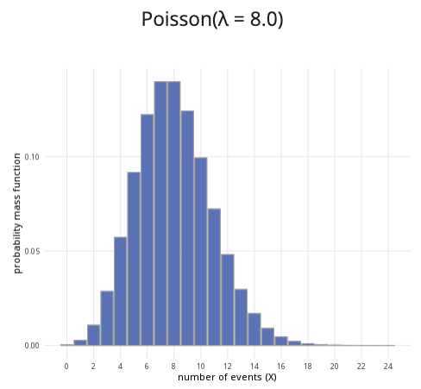
An example of the Poisson distribution with $λ=8$.
Where to use: The Poisson distribution is used when a specific event occurs at some rate $λ$, and you are counting $X$, the number of times this event occurs in some interval.
Notation: $X∼\text{Poisson}\left(λ\right)$ or $X∼\text{Pois}\left(λ\right)$.
Parameter: $λ$ is the integer number of times an event occurs within a specific period of time.
Quantity | Value | Notes
Mean | $E\left(X\right)=λ$
Variance | $V\left(X\right)=λ$
PMF | $P\left(X=x\right)=\frac{λ^{x}e^{−λ}}{x!}$
CDF | $P\left(X≤x\right)=\sum_{i=1}^{⌊x⌋}{\frac{λ^{x}e^{−λ}}{x!}}$ | $⌊x⌋$ the floor function
Example: Customers enter Cantor’s Confectionery at an average rate of 20 people per hour, and you want to see the likelihood that $X$ number of customers walks in. This can be expressed as $X∼\text{Pois}\left(20\right)$.

Further reading
This interactive element appears in Overview: Probability distributions. Please click this link to go to the guide.

Version history
v1.0: initial version created 04/25 by tdhc and Michelle Arnetta as part of a University of St Andrews VIP project.
- v1.1: moved to factsheet form and populated with material from Overview: Probability distributions by tdhc.
This work is licensed under CC BY-NC-SA 4.0.

