Factsheet: Geometric distribution
Michelle Arnetta and Tom Coleman
Summary
A factsheet for the geometric distribution.
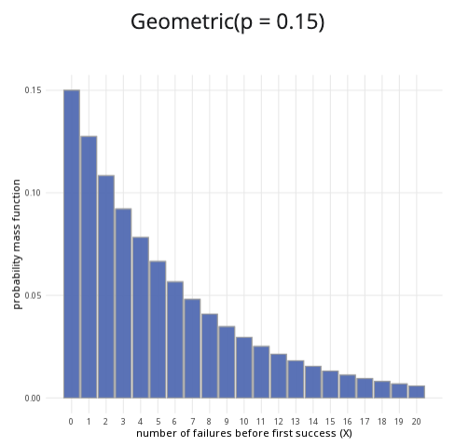
An example of the geometric distribution with $p=0.15$.
Where to use: The geometric distribution is used to count $X$, the number of Bernoulli trials until a successful outcome is reached.
Notation: $X∼\text{Geometric}\left(p\right)$
Parameter: $p$ is the real number representing the probability of success in a single trial (where $0≤p≤1$).
Quantity | Value | Notes
Mean | $E\left(X\right)=\frac{1}{p}$
Variance | $V\left(X\right)=\frac{1−p}{p^{2}}$
PMF | $P\left(X=x\right)={\left(1−p\right)}^{k−1}p$
CDF | $P\left(X≤x\right)=\left\{\begin{matrix}1−{\left(1−p\right)}^{x} & \text{if }x≥0 \\ 0 & \text{if }x<0\end{matrix}\right.$
Example: You flip a coin multiple times, and the probability of getting ‘heads’ is $0.5$. You decide to stop flipping the coin once you get a ‘heads’. Taking ‘heads’ as a success, this can be expressed as $X∼\text{Geometric}\left(0.5\right)$. It means the probability of success is $0.5$, and you will stop conducting trials after you reach a success.

Further reading
This interactive element appears in Overview: Probability distributions. Please click this link to go to the guide.

Version history
v1.0: initial version created 04/25 by tdhc and Michelle Arnetta as part of a University of St Andrews VIP project.
- v1.1: moved to factsheet form and populated with material from Overview: Probability distributions by tdhc.
This work is licensed under CC BY-NC-SA 4.0.

