Factsheet: Gamma distribution
Michelle Arnetta and Tom Coleman
Summary
A factsheet for the gamma distribution.
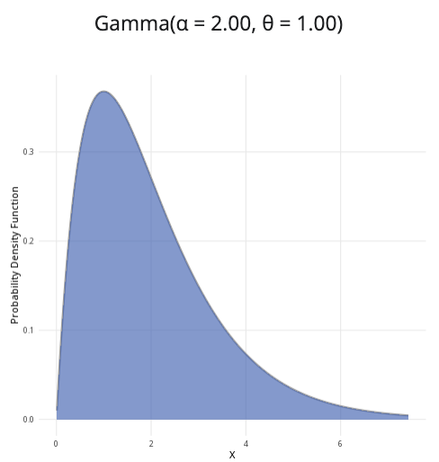
An example of the gamma distribution with $α=2$ and $θ=1$.
Where to use: The gamma distribution generalizes the exponential distribution, allowing for greater or lesser variance. It is used to model positive continuous random variables that have skewed distributions.
Notation: $X∼\text{Gamma}\left(α,θ\right)$ or $X∼\text{Gam}\left(α,θ\right)$
Parameters: Two real numbers $α$ and $θ$, which are related to the mean $μ$ and variance $σ^{2}$:
- $α=\frac{μ^{2}}{σ^{2}}$ (shape parameter)
- $θ=\frac{σ^{2}}{μ}$ (scale parameter)
Quantity | Value | Notes
Mean | $E\left(X\right)=αθ$
Variance | $V\left(X\right)=αθ^{2}$
PDF | $P\left(X=x\right)=\frac{x^{α−1}exp\left(−\frac{x}{θ}\right)}{Γ\left(α\right)θ^{α}}$ | $Γ\left(x\right)$ the gamma function of $x$
CDF | $P\left(X≤x\right)=\frac{\text{Gam}\left(α,\frac{x}{θ}\right)}{Γ\left(α\right)}$ | $\text{Gam}\left(α,θ\right)$ is the PDF of the gamma distribution
Example: You collect historical data on the time to failure of a machine from Cantor’s Confectionery. The mean is 83 days and the variance is 50.3. You can then use this to estimate the shape and scale parameters of the gamma distribution:
- $α=\frac{{83}^{2}}{50.3}=136.958250497≈137$
- $θ=\frac{50.3}{83}=0.60602409638≈0.61$
The distribution can be expressed as $X∼\text{Gam}\left(137,0.61\right)$, where the shape parameter is 137 and the scale parameter is 0.61.

Further reading
This interactive element appears in Overview: Probability distributions. Please click this link to go to the guide.

Version history
v1.0: initial version created 04/25 by tdhc and Michelle Arnetta as part of a University of St Andrews VIP project.
- v1.1: moved to factsheet form and populated with material from Overview: Probability distributions by tdhc.
This work is licensed under CC BY-NC-SA 4.0.

