Factsheet: Discrete uniform distribution
Michelle Arnetta and Tom Coleman
Summary
A factsheet for the discrete uniform distribution.
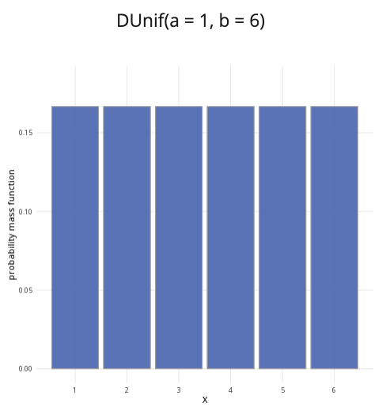
An example of the discrete uniform distribution with $a=1$ and $b=6$.
Where to use: The discrete uniform distribution is used when all integer outcomes $x$ in the interval $a$ to $b$ are equally likely. $X$ is a random variable for integer outcomes $x$ where for $a≤x≤b$, and the probability of each outcome $1/n$, where $n=b−a+1$.
Notation: $X∼\text{Uniform}\left(a,b\right)$ or $X∼U\left(a,b\right)$
Parameters: The numbers $a,b$ are integers where
- $a$ is the minimum value of an outcome
- $b$ is the maximum value of an outcome
There are $n$ outcomes in total, with $n=b−a+1$.
Quantity | Value | Notes
Mean | $E\left(X\right)=\frac{a+b}{2}.$
Variance | $V\left(X\right)=\frac{n^{2}−1}{12}.$
PMF | $P\left(X=x\right)=\frac{1}{n}$
CDF | $P\left(X≤x\right)=\left\{\begin{matrix}0 & \text{if }x≤a \\ \frac{⌊x⌋−a+1}{n} & \text{if }a<x<b \\ 1 & \text{if }x≥b\end{matrix}\right.$ | $⌊x⌋$ is the floor function
Example: You roll a fair six-sided die, where all outcomes ($1,2,3,4,5,$ and $6$) are equally likely. This can be expressed as $X∼U\left(1,6\right)$. It means $1$ is the minimum value and $6$ is the maximum value, where all discrete values of $X$ for $1≤x≤6$ are equally likely.

Further reading
This interactive element appears in Overview: Probability distributions.

Version history
v1.0: initial version created 08/25 by tdhc.
This work is licensed under CC BY-NC-SA 4.0.

