Factsheet: Continuous uniform distribution
Michelle Arnetta and Tom Coleman
Summary
A factsheet for the continuous uniform distribution.
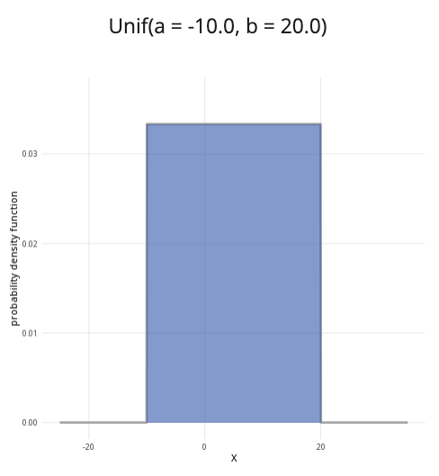
An example of the continuous uniform distribution with $a=−10$ and $b=20$.
Where to use: The continuous uniform distribution is used when all continuous values $x$ in the interval $a$ to $b$ are equally likely. The random variable $X$ represents the outcome.
Notation: $X∼\text{Uniform}\left(a,b\right)$ or $X∼U\left(a,b\right)$.
Parameters: Two real numbers $a,b$, where
- $a$ is the minimum value of an outcome,
- $b$ is the maximum value of an outcome.
Quantity | Value | Notes
Mean | $E\left(X\right)=\frac{a+b}{2}$
Variance | $V\left(X\right)=\frac{{\left(b−a\right)}^{2}}{12}$
PDF | $P\left(X=x\right)=\left\{\begin{matrix}\frac{1}{b−a} & \text{if }a≤x≤b \\ 0 & \text{otherwise}\end{matrix}\right.$
CDF | $P\left(X≤x\right)=\left\{\begin{matrix}0 & \text{if }x<a \\ \frac{x−a}{b−a} & \text{if }a≤x≤b \\ 1 & \text{if }x>b\end{matrix}\right.$
Example: A machine from Cantor’s Confectionery is programmed to chop long candy bars into pieces, each with a length between 30 millimetres to 50 millimetres. Due to variations in the machine, each continuous value between this interval is equally likely. This can be expressed as $X∼U\left(30,50\right)$. It means 30 is the minimum value and 50 is the maximum value, where all continuous values of $X$ for $30≤x≤50$ are equally likely.

Further reading
This interactive element appears in Overview: Probability distributions.

Version history
v1.0: initial version created 08/25 by tdhc.
This work is licensed under CC BY-NC-SA 4.0.

