Factsheet: Binomial distribution
Michelle Arnetta and Tom Coleman
Summary
A factsheet on the binomial distribution.
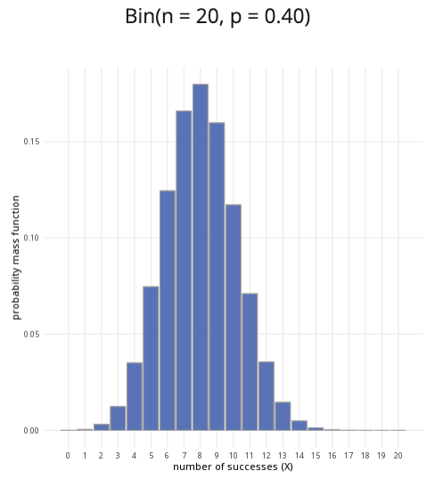
An example of the binomial distribution with $n=20$ and $p=0.4$.
Where to use: The binomial distribution is used when there are a fixed number of trials ($n$) and only two possible outcomes for each trial, representing $n$ many Bernoulli trials. Here, the random variable $X$ represents the number of successes.
Notation: $X∼\text{Binomial}\left(n,p\right)$ or $X∼B\left(n,p\right)$.
Parameters: Two numbers $n,p$ where: - $n$ is an integer representing the number of trials, - $p$ is a real number representing the probability of success of a trial (where $0≤p≤1$).
Quantity | Value | Notes
Mean | $E\left(X\right)=np$
Variance | $V\left(X\right)=np\left(1−p\right)$
PMF | $P\left(X=x\right)=\frac{n!}{\left(n−x\right)!x!}p^{x}q^{\left(n−x\right)}$
CDF | $P\left(X≤x\right)=I_{q}\left(n−⌊x⌋,1+⌊x⌋\right)$ | $I_{x}\left(a,b\right)$ regularized incomplete beta function, $⌊x⌋$ the floor function
Example: You flip a coin $10$ times, and the probability of getting ‘heads’ is $0.5$. Taking ‘heads’ as a success, this can be expressed as $X∼B\left(10,0.5\right)$, meaning $10$ trials are conducted, where the probability of success in each trial is $0.5$.

Further reading
This interactive element appears in Guide: PMFs, PDFs, CDFs and Overview: Probability distributions. Please click the relevant links to go to the guides.

Version history
v1.0: initial version created 04/25 by tdhc and Michelle Arnetta as part of a University of St Andrews VIP project.
- v1.1: moved to factsheet form and populated with material from Overview: Probability distributions by tdhc.
This work is licensed under CC BY-NC-SA 4.0.

