Answers: Trigonometry (degrees)
Dzhemma Ruseva, Ellie Gurini, Ciara Cormican
Summary
Answers to the questions on trigonometry, using degrees to measure angles.
These are the answers to Questions: Trigonometry (degrees).
Please attempt the questions before reading these answers!

Q1
You are given the triangle below.
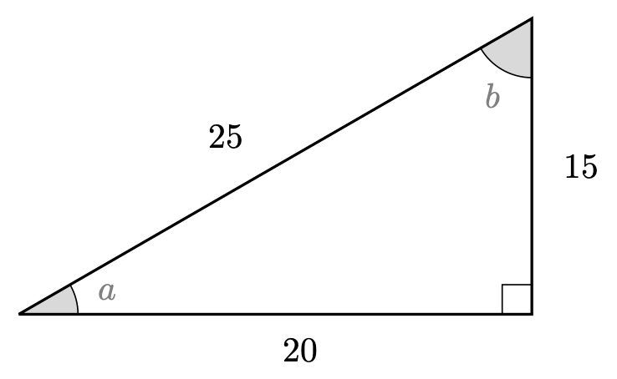
Q1. Triangle
Here,
- $cos\left(a\right)=\frac{4}{5}$
- $sin\left(a\right)=\frac{3}{5}$
- $tan\left(a\right)=\frac{3}{4}$
- $cos\left(b\right)=\frac{3}{5}$
- $sin\left(b\right)=\frac{4}{5}$
- $tan\left(b\right)=\frac{4}{3}$

Q2
Using the triangle below, solve the following equations.
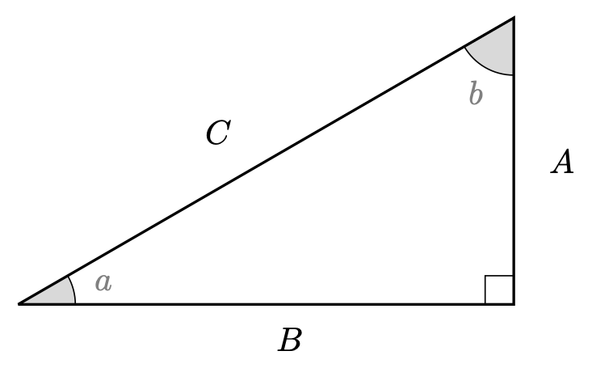
Q2. Triangle
2.1. $C=12$
2.2. $A=2$
2.3. $A=1.812$ (to three decimal places)
2.4. $A=\sqrt{6}$
2.5. $A=8$
2.6. $B=\frac{8}{\sqrt{3}}$.

Q3
3.1. $cos\left(30\right)=\frac{\sqrt{3}}{2}$
3.2. $tan\left(30\right)=\frac{1}{\sqrt{3}}=\frac{\sqrt{3}}{3}$
3.3. $csc\left(45\right)=1$
3.4. $cot\left(30\right)−sin\left(60\right)=\sqrt{3}−\frac{\sqrt{3}}{2}=\frac{\sqrt{3}}{2}$
3.5. $sin\left(90\right)+cos\left(180\right)=1+\left(−1\right)=0$
3.6. $tan\left(30\right)−cot\left(30\right)=\frac{1}{\sqrt{3}}−\sqrt{3}$
3.7. $cos\left(0\right)sin\left(90\right)=1⋅1=1$
3.8. $cos\left(30\right)sec\left(30\right)−sin\left(45\right)csc\left(45\right)=1−1=0$
3.9. $cot\left(90\right)=0$

Version history and licensing
v1.0: initial version created 08/23 by Dzhemma Ruseva, Ellie Gurini, Ciara Cormican as part of a University of St Andrews STEP project.
- v1.1: edited 05/24 by tdhc, and split into versions for both degrees and radians.
This work is licensed under CC BY-NC-SA 4.0.

