Answers: Introduction to probability
Michelle Arnetta
Summary
Answers to questions relating to the guide on introduction to probability.
These are the answers to Questions: Introduction to probability.
Please attempt the questions before reading these answers!

Q1
(Note: accept all simplified fractions, or probabilities represented in decimal and percentage forms)
1.1.
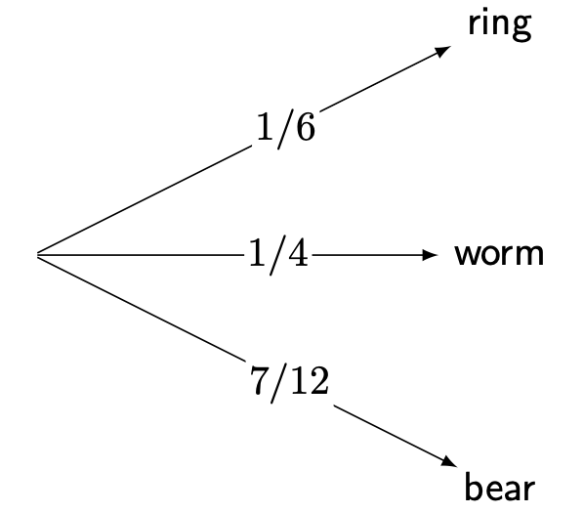
Answer to Q1.1(a)
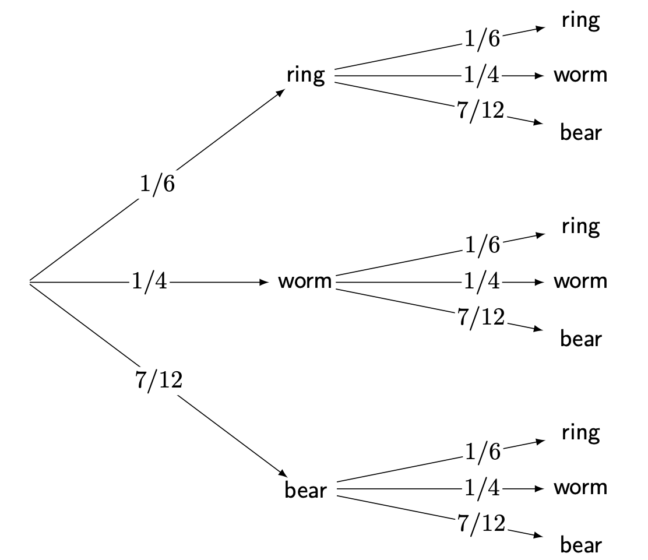
Answer to Q1.1(b)
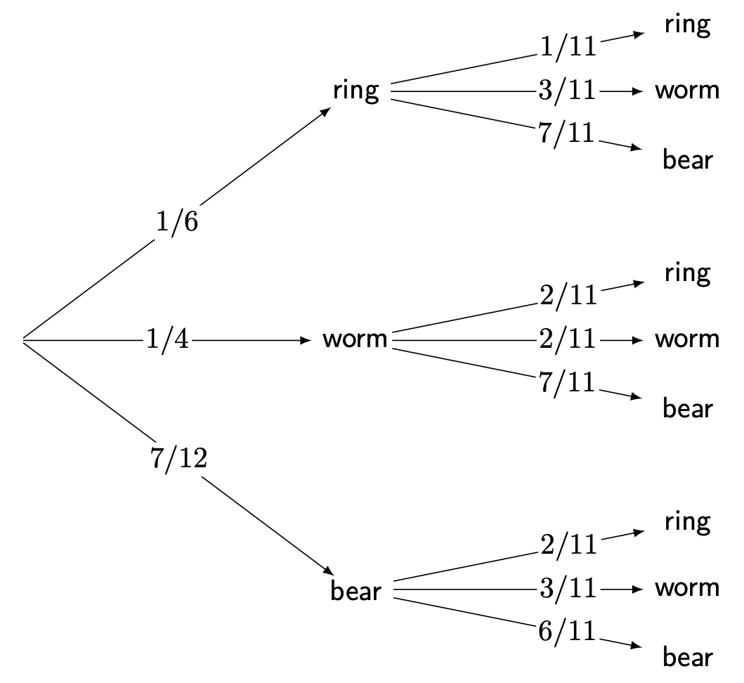
Answer to Q1.1(c)
1.2.
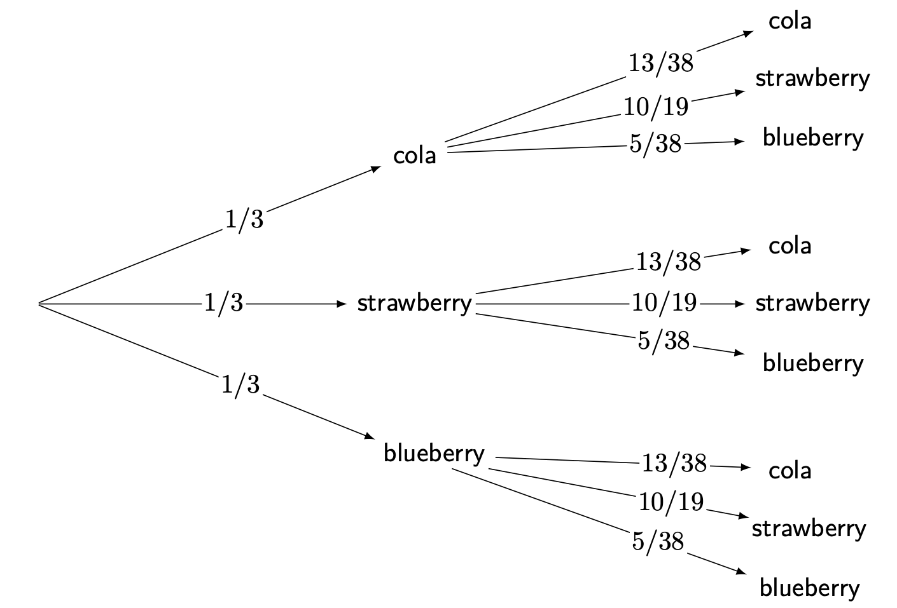
Answer to Q1.2
1.3.
- The events in Q1.1.(b) are independent.
- The events in Q1.1.(c) are dependent.
- The events in Q1.2. are independent.

Q2
(Note: accept all simplified fractions, or probabilities represented in decimal and percentage forms)
2.1.
- $P\left(\text{gummy bear}\right)=\frac{7}{12}$. Therefore, apply the complement rule to calculate the complement of $P\left(\text{gummy bear}\right)$, so $P\left(\text{gummy bear}′\right)=1−\frac{7}{12}=\frac{5}{12}$.
- The probability of drawing a gummy ring the first time is $\frac{2}{12}$, and the probability of drawing a gummy ring the second time is also $\frac{2}{12}$. Therefore, $P\left(\text{gummy ring and gummy ring}\right)=\left(\frac{2}{12}\right)\left(\frac{2}{12}\right)=\frac{4}{144}=\frac{1}{36}$.
- The probability of drawing a gummy bear the first time is $\frac{7}{12}$, and the probability of drawing a gummy worm the second time is $\frac{3}{11}$. Therefore, $P\left(\text{gummy bear then gummy worm}\right)=\left(\frac{7}{12}\right)\left(\frac{3}{11}\right)=\frac{21}{132}=\frac{7}{44}$.
2.2. The probability of drawing a cola flavored jelly bean the first time is $\frac{10}{30}$, and the probability of drawing a strawberry flavored jelly bean the second time is $\frac{20}{38}$. Therefore, $P\left(\text{soda and strawberry}\right)=\left(\frac{10}{30}\right)\left(\frac{20}{38}\right)=\frac{200}{1140}=\frac{10}{57}$.

Q3
3.1. This is an example of experimental probability.
3.2. The total number of spins is 60, and it lands on white 17 times. Therefore, $P\left(\text{white}\right)=\frac{17}{60}$, so by the complement rule, $P\left(\text{white}′\right)=1−\frac{17}{60}=\frac{43}{60}$.
3.3. The spinner is unbiased (meaning the probability is uniform), so there are four possible colors that the spinner is equally likely to land on. Calculating the theoretical probability, $P\left(\text{red}\right)=\frac{1}{4}$.
3.4. As you spin the spinner more times, the experimental probabilities of each color will get closer to their theoretical probabilities.

Q4
4.1. The sample space is $\{1,2,3,4,5,6,7,8,9,10,11,12,13,14,15,16,17,18,19,20\}$, which contains 20 possible outcomes. The subset of the sample space with a value above 12 is $\{13,14,15,16,17,18,19,20\}$, which contains 8 out of the 20 possible outcomes. Therefore, $P\left(\text{success}\right)=\frac{8}{20}=\frac{2}{5}$.
4.2. The possible outcomes of the 5-sided dice roll are $\{1,2,3,4,5\}$. Adding 3 to each number, the sample space becomes $\{\left(1+3\right),\left(2+3\right),\left(3+3\right),\left(4+3\right),\left(5+3\right)\}=\{4,5,6,7,8\}$. The sample space contains 5 possible outcomes, and the subset of the sample space that contains values 5 and above is $\{5,6,7,8\}$, which contains 4 out of 5 possible outcomes. Therefore, $P\left(x≥5\right)=\frac{4}{5}$ where $x$ points of damage are dealt to the dragon.
4.3. Here is the sample space represented as a table:
 | 1 | 2 | 3 | 4
1 | (1,1) | (1,2) | (1,3) | (1,4)
2 | (2,1) | (2,2) | (2,3) | (2,4)
3 | (3,1) | (3,2) | (3,3) | (3,4)
4 | (4,1) | (4,2) | (4,3) | (4,4)
For convenience purposes, all outcomes that do not contain a 4 are then marked with an asterisk (although any way of marking or counting these outcomes are acceptable):
 | 1 | 2 | 3 | 4
1 | (1,1)* | (1,2)* | (1,3)* | (1,4)
2 | (2,1)* | (2,2)* | (2,3)* | (2,4)
3 | (3,1)* | (3,2)* | (3,3)* | (3,4)
4 | (4,1) | (4,2) | (4,3) | (4,4)
There are 16 total possible outcomes in the sample space, and there are 9 outcomes that do not contain a 4. Therefore, $P\left(\text{failure}\right)=\frac{9}{16}$.
4.4. Here is the sample space represented as a table:
 | 1 | 2 | 3 | 4
1 | (1,1) | (1,2) | (1,3) | (1,4)
2 | (2,1) | (2,2) | (2,3) | (2,4)
3 | (3,1) | (3,2) | (3,3) | (3,4)
4 | (4,1) | (4,2) | (4,3) | (4,4)
5 | (5,1) | (5,2) | (5,3) | (5,4)
6 | (6,1) | (6,2) | (6,3) | (6,4)
7 | (7,1) | (7,2) | (7,3) | (7,4)
8 | (8,1) | (8,2) | (8,3) | (8,4)
9 | (9,1) | (9,2) | (9,3) | (9,4)
The results of the two dice rolls can then be added together:
 | 1 | 2 | 3 | 4
1 | 2 | 3 | 4 | 5
2 | 3 | 4 | 5 | 6
3 | 4 | 5 | 6 | 7
4 | 5 | 6 | 7 | 8
5 | 6 | 7 | 8 | 9
6 | 7 | 8 | 9 | 10
7 | 8 | 9 | 10 | 11
8 | 9 | 10 | 11 | 12
9 | 10 | 11 | 12 | 13
For convenience purposes, all outcomes with skill levels that are greater than 9 are then marked with an asterisk (although any way of marking or counting these outcomes are acceptable):
 | 1 | 2 | 3 | 4
1 | 2 | 3 | 4 | 5
2 | 3 | 4 | 5 | 6
3 | 4 | 5 | 6 | 7
4 | 5 | 6 | 7 | 8
5 | 6 | 7 | 8 | 9
6 | 7 | 8 | 9 | 10*
7 | 8 | 9 | 10* | 11*
8 | 9 | 10* | 11* | 12*
9 | 10* | 11* | 12* | 13*
There are 36 total possible outcomes in the sample space, and there are 10 outcomes where the skill level exceeds 9 points. Therefore, $P\left(x>9\right)=\frac{10}{36}=\frac{5}{18}$ where $x$ is the number of skill level points.

Version history and licensing
v1.0: initial version created 04/25 by Michelle Arnetta as part of a University of St Andrews VIP project.
This work is licensed under CC BY-NC-SA 4.0.

